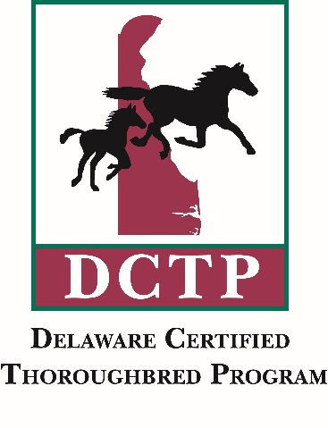
Delaware Certified List –2019 Midlantic Fall Yearlings Sale – Sept 30 – Oct 1
List By Hip #
Hip #6 Alottalute -Street Magician, ch, f – Becky Davis – Barn B-C
Hip #11 Andean – Bernardini,b, c. – CandyLand – Barn I-J
Hip #17 Apple Pie Baby – Liam’s Map,gr/rn,f – CandyLand – Barn I-J
Hip #20 As Long as Ittakes-Mosler,b,f – Bill Reightler – Barn I-J
Hip #22 Avani Force – Bullsbay,b, f – Marshall Silverman – Barn J-K
Hip #41 Bombshell Babe – Uncle Lino, gr/rn,c – Northview Stallion Station – Barn C-D
Hip #42 Boyd’s Bargain – Imagining,ch, c – CandyLand – Barn I-J
Hip #60 Citzen Emma – Cross Traffic, gr/rn,c – CandyLand – Barn I-J
Hip #77 D D Renegade – Cinco Charlie,drkb/b, c – CandyLand Barn I-J
Hip #101 E Dubai’s Humor – Imagining, ch, c – Bill Reightler Barn I-J
Hip #114 Figlia D’Oro – Imagining,b, c – CandyLand Barn I-J
Hip #115 Final Humor – Mosler,b, c – Bill Reightler Barn I-J
Hip # 133 Frivolous Flo – Upstart,b, f – CandyLand Barn I-J
Hip #137 Gansett – Mosler b, c – Bill Reightler Barn I-J
Hip #158 Heart Seeker – Violence,b, f – CandyLand Barn I-J
Hip #169 Holy Princess – Not This Time,b, c – CandyLand Barn I-J
Hip # 170 Hoping for Sun – Gio Ponti – NOT DELAWARE CERTIFIED
Hip # 171 Hot Fun – Mosler,b, f – Bill Reightler Barn I-J
Hip # 177 Irina Baranova – Imagining, b,c – Becky Davis Barn B-C
Hip # 235 Mountain Vow – Wicked Strong, b, f – CandyLand Barn I-J
Hip # 237 Mrs Vanderbilt – Honor Code,b, c – Bill Reightler Barn I-J
Hip #259 Patel – Mosler, gr/rn, c – Northview Stallion Station Barn B-C
Hip #279 Prom Queen – Bandbox,gr/rn,c – Northview Stallion Station Barn C-D
Hip #288 Raiders Fan – Birdstone,ch,c – Bill Reightler Barn I-J
Delaware Certified List –2019 Midlantic Fall Yearlings Sale – Sept 30 – Oct 1

Hip #295 Rebel Lady – Soaring Empire, drkb/b, f – Marshall Silveman Barn J-K
Hip #296 Red Bank Robin – Weigelia,b, f – WynOaks Farm Barn K
Hip #306 R Icee One – Violence, drkb,f – CandyLand Barn I-J
Hip #318 Ruby Rubles – Gemologist,ch, f – CandyLand Barn I-J
Hip #323 San Gregoria – Bullsbay,drkb/b,c – Northview Stallion Station Barn C-D
Hip #342 Silver Heart – Liam’s Map,gr/rn,f – CandyLand Barn I-J
Hip #346 Slow and Steady – Buffum, b, f – CandyLand Barn I-J
Hip #352 Spanish Dream – Buffum,drkb/b,c – Northview Stallion Station Barn C-D
Hip #357 Steady N Love – Shackleford,b, c – CandyLand Barn I-J
Hip #369 Tasha’s Moon – Into Mischief,b, f – CandyLand Barn I-J
Hip #375 Thrill Seeker – Lookin at Lucky, ch, c – La Rain Farm Barn B
Hip #379 Toasty – Palace Malice,drkb/b,f – CandyLand Barn I-J
Hip #381 Top Coat – Imagining,drkb/b, f – Becky Davis Barn B-C
Hip #403 Winds of Change – Mshawish,ch, c – CandyLand Barn I-J
Hip #408 Yolie’s Choice – Exaggerator, drkb/b,f – CandyLand Barn I-J

